Road markings detection and road measurement in aerial imagery

Raiyan Diwan

Deeprajsinh Gohil

Vats Patel

Tejas Pansuriya

*Abstract*—This project aims to develop a robust model for detecting the presence or absence of road markings in aerial imagery using semantic segmentation techniques, integrating a ResNet-50 architecture within a UNet framework. The model utilizes pre-trained weights from ImageNet for efficient feature learning. The AU drone dataset serves as the test bed for training and validating the model. Road markings play a vital role in guiding drivers and pedestrians, and automating their detection enhances road safety and traffic management. By employing deep learning methods, specifically semantic segmentation, this project contributes to the accurate identification of road markings in aerial imagery, thus improving navigation systems and urban planning.

Keywords—Road markings, Aerial imagery, Semantic segmentation, Deep learning, ResNet-50, UNet, ImageNet.

# Introduction

Road markings are essential visual cues on roadways, providing critical information to motorists and pedestrians for safe navigation. Detecting road markings in aerial imagery is a challenging yet crucial task with various applications in traffic management, urban planning, and navigation systems. This project focuses on developing an efficient model for automatically detecting road markings in aerial images using deep learning techniques.

II. Methodology

## Data Preprocessing:

The AU drone dataset, comprising aerial imagery captured by drones, is utilized for training and testing the model. The dataset is annotated to label road markings, facilitating supervised learning. During data preprocessing, instead of using the entire original image of dimension 960x576, the images are divided into six patches of size 256x256x3. This approach minimizes data loss and enhances computational efficiency.

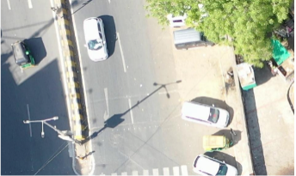 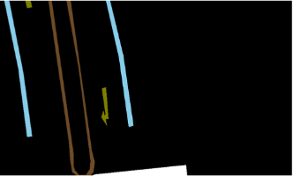

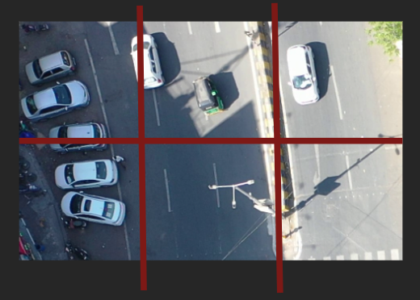

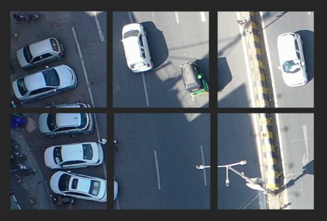

## Model Architecture:

## The model architecture incorporates a UNet framework with a ResNet-50 backbone for semantic segmentation. This architecture enables the model to learn intricate features of road markings while preserving spatial information.

## Transfer Learning:

## Pre-trained weights from ImageNet are used to initialize the ResNet-50 backbone, allowing the model to leverage learned features for improved performance and faster convergence during training.

## Data-Training:

The model is trained using the annotated AU drone dataset, optimizing for accurate segmentation of road markings. Training involves minimizing a suitable loss function, such as binary cross-entropy, to align predicted segmentation masks with ground truth annotations.

## Evaluation:

The trained model is evaluated on a separate test set from the AU drone dataset to assess its performance in accurately detecting road markings. Metrics such as Intersection over Union (IoU) and accuracy are calculated to measure segmentation performance.

# Results

The developed model demonstrates robust performance in detecting road markings in aerial imagery. By leveraging semantic segmentation techniques and the ResNet-50 backbone within a UNet architecture, the model achieves accurate segmentation of road markings, contributing to enhanced road safety and traffic management.

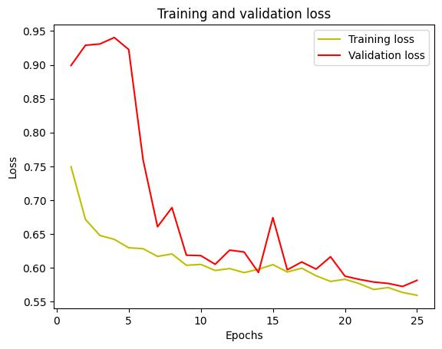

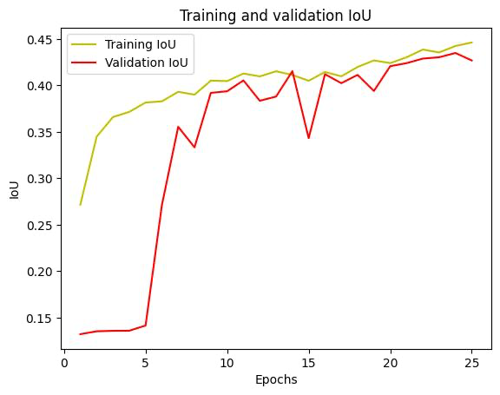

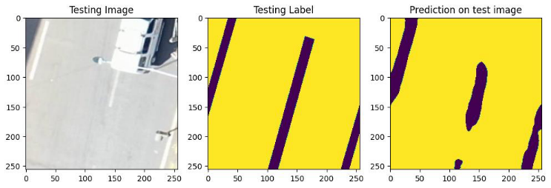

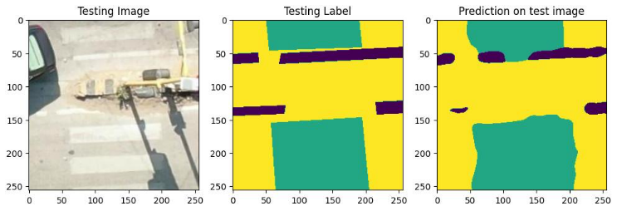

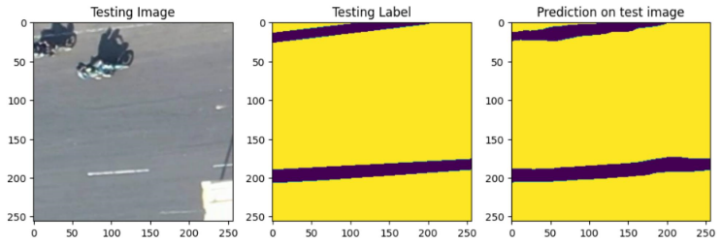

# Conclusion

##### In conclusion, this project successfully develops a deep learning model for detecting road markings in aerial imagery. By employing semantic segmentation with a UNet architecture and integrating a ResNet-50 backbone with pre-trained weights from ImageNet, the model achieves accurate segmentation of road markings. The findings of this project offer significant implications for improving navigation systems, urban planning, and traffic management through automated detection of road markings. Future work may involve further refining the model and exploring additional datasets for validation and generalization. Additionally, the utilization of patch-based data preprocessing proves effective in minimizing data loss and enhancing computational efficiency.

##### References

1. S. M. Azimi, P. Fischer, M. Körner, and P. Reinartz, “Aerial LaneNet: Lane marking semantic segmentation in aerial imagery using wavelet-enhanced cost-sensitive symmetric fully convolutional neural networks,” arXiv.org, <https://arxiv.org/abs/1803.06904>.
2. G. Haiyan, X. Lei, Y. Yu, and H. Zhao, “Road marking extraction in UAV imagery using attentive capsule feature Pyramid Network,” International Journal of Applied Earth Observation and Geoinformation, <https://www.sciencedirect.com/science/article/pii/S0303243422000034>.
3. “Image segmentation : Tensorflow Core,” TensorFlow, <https://www.tensorflow.org/tutorials/images/segmentation>.